Name:  Teacher: | ____________________________________  ________________ |  | Date:_________
 | Year 8 Mathematics  SCORE: / 22  Mini test 8  Topic – Congruency  Full working out MUST be shown to get full marks for each question.
Total Time: | 30 minutes
Weighting: | 5%
Equipment: | To be provided by the student: Pens and Pencils, scientific calculator, A4 page of notes.

- [4 marks]
The following are pairs of congruent triangles

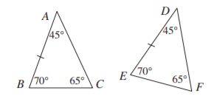 | 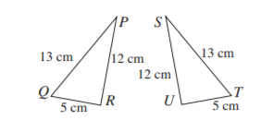
- Which side corresponds to AC?  - Write the congruency statement | - Which angle corresponds to ∠QRP?  - Write the congruency statement.

- [4 marks]
Write the congruency test for each of the following pairs of congruent triangles
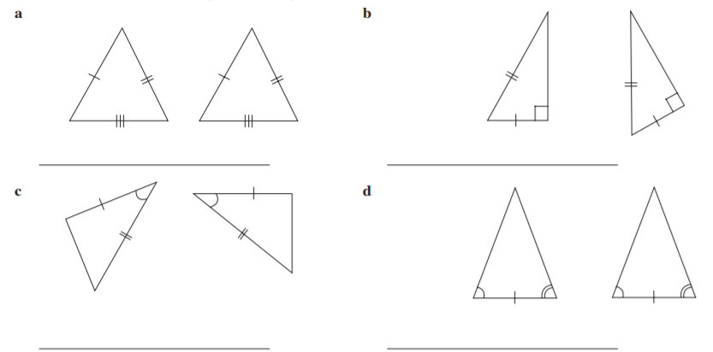

- [3 marks]
If the triangles are congruent determine the unknown values for a, b and c
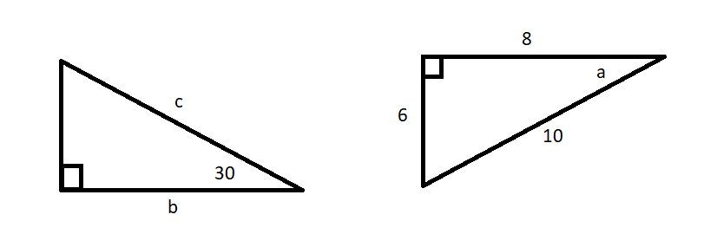

- [4 marks]
Consider the following parallelogram

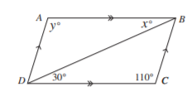
- What is the value of x?

- What is the value of y?

- Write the congruency statement for the 2 triangles

- Under what transformation will map one triangle to the other?

- [3 marks]
Which of the following triangles are congruent? Why?

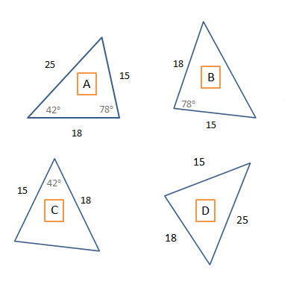

- [4 marks]
When a rectangle has a diagonal drawn across it, it will form two triangles. Explain why these two triangles are congruent.

END OF TEST

